FCH1 -

Functionality
This transaction allows you to display more detailed check information via the check number. From the check information display, you can request details on the check recipient and the check issuer as well as branch to display of the corresponding payment and invoice documents.

Scenario
You want to display previously posted check.

Requirements
Posted check payment

Menu Path | Accounting → Financial Accounting → Accounts Payable → Environment → Check information → Display → FCH1 - For check
Transaction Code | FCH1

1. Double click on FCH1 - For check.

Display Check Information

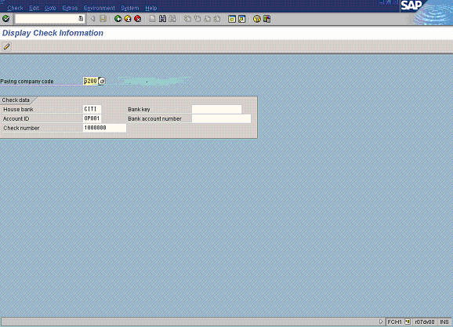

2. Update the following fields:

Field Name | Field Description | Values
Paying company code | In this field you find the company code that processes the payment transactions (possibly for other company codes too). | Example: 5200
House bank | Identification number for the house bank to which the transaction corresponds | Example: CITI
Account ID | Code identifying the account to which the General Ledger account corresponds | Example: OP001
Check number | Enter the required check number | Example: 1000000

Tip: If you don’t know your check number, press Press [F4] or click the button in the Check Number field

3. Click Enter Button to confirm your entries.

Display Check Information

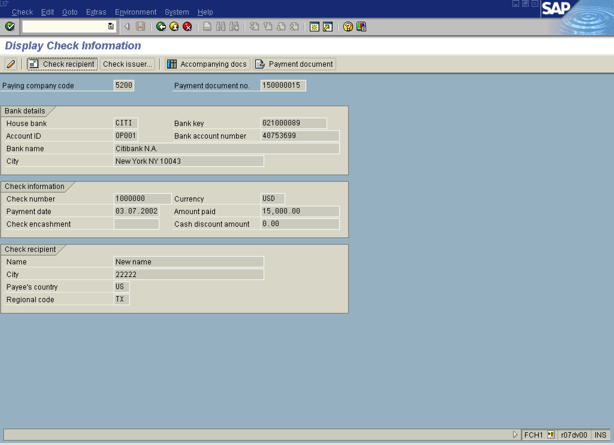

4. Click Check recipient Button . The system will display for whom the check was issued:

Check Recipient

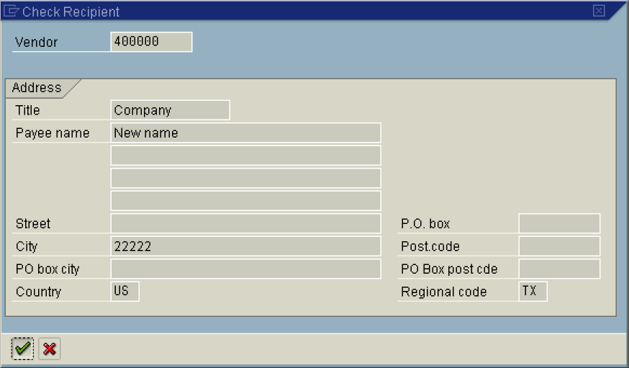

5. Click Enter Button. to close this screen.

Display Check Information

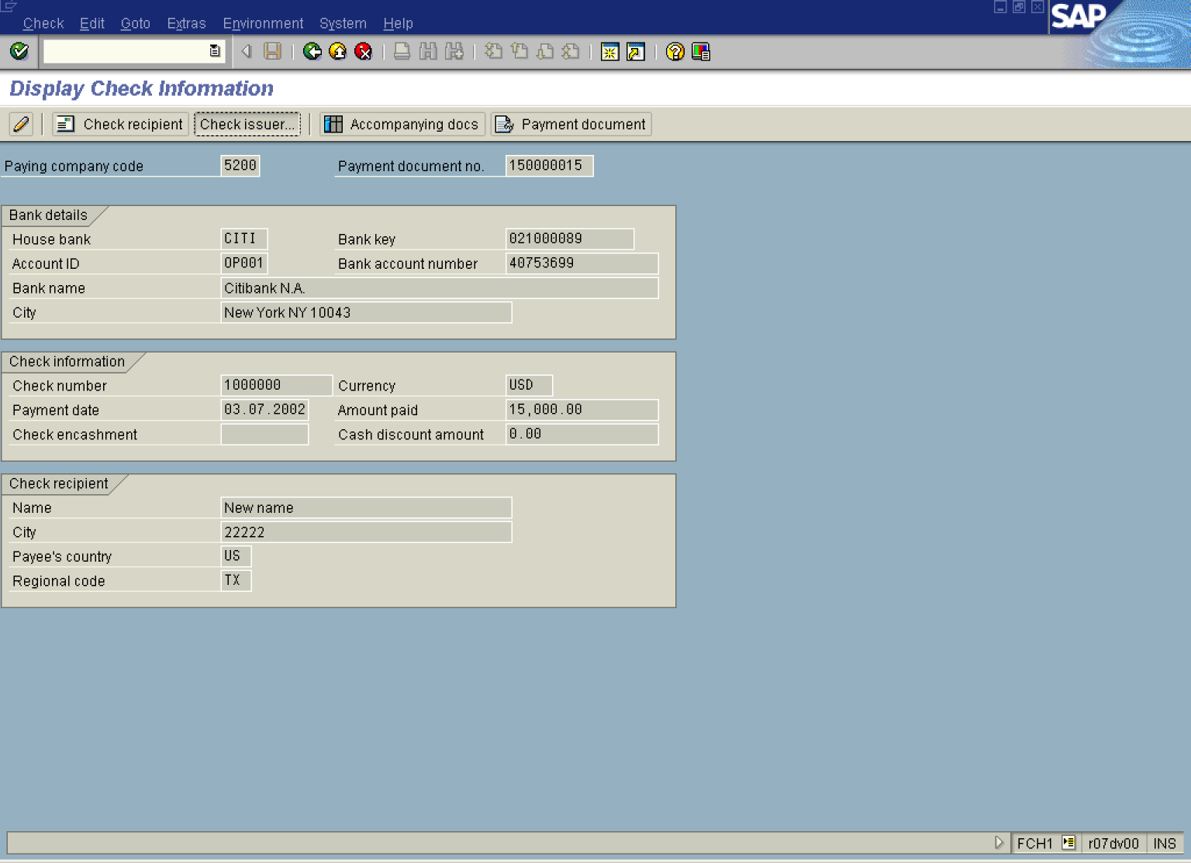

6. Click Check issuer... Button . You will see the user details that posted the check transaction:

7. Click Enter Button.

Display Check Information

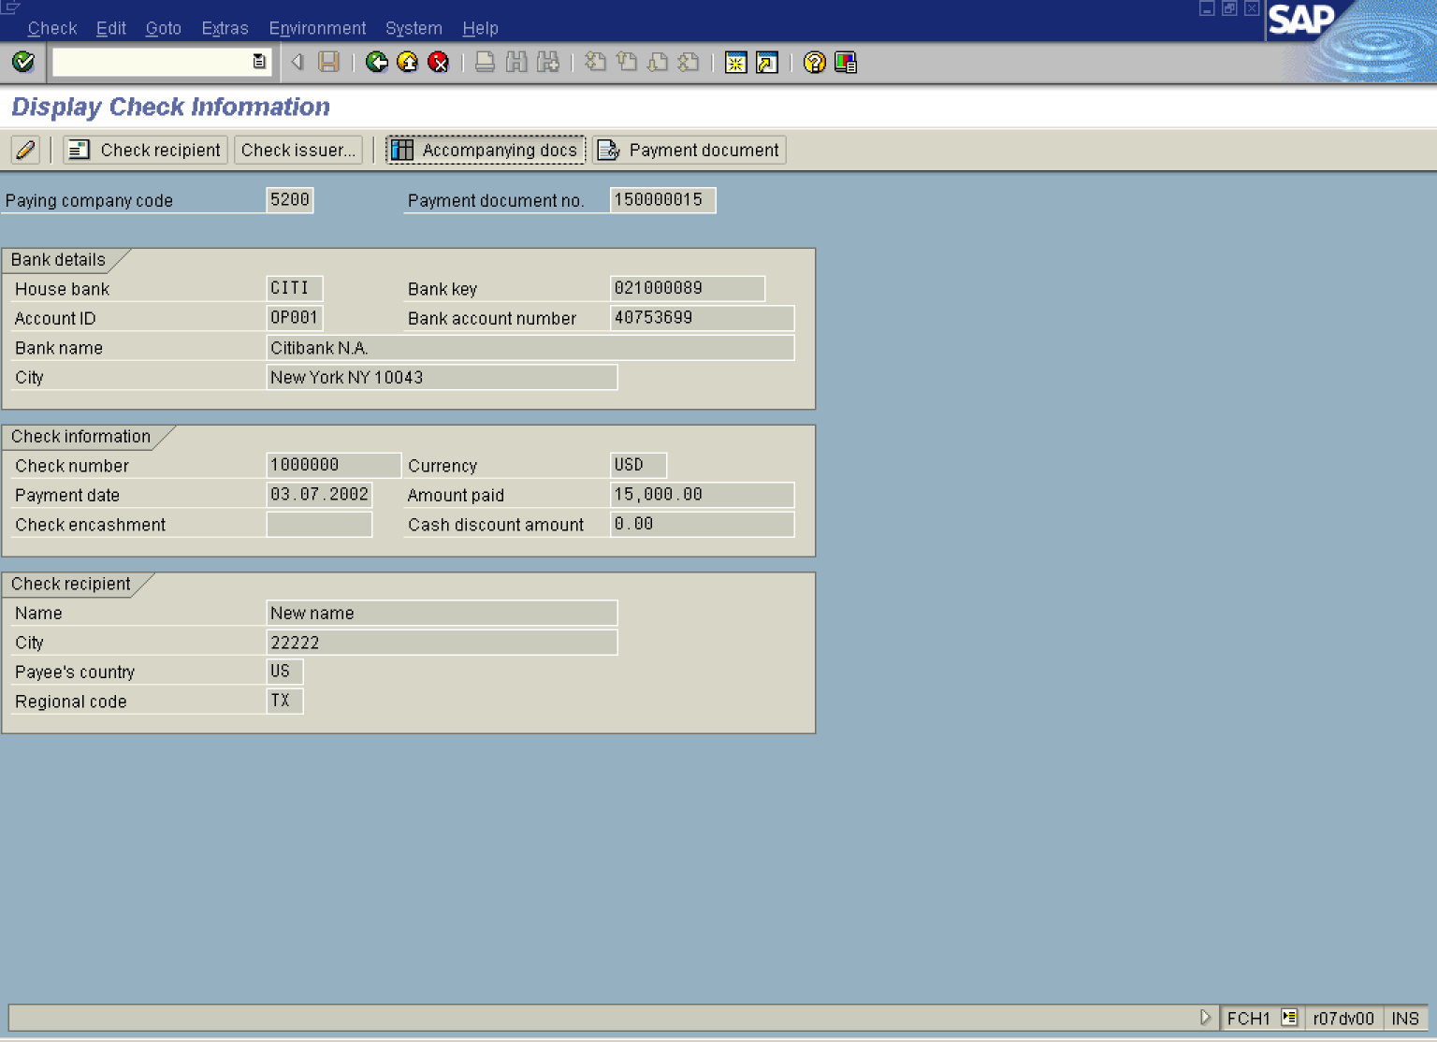

8. Click Accompanying docs Button . The system will display the accounting document(s) regarding this posting:

Check line items

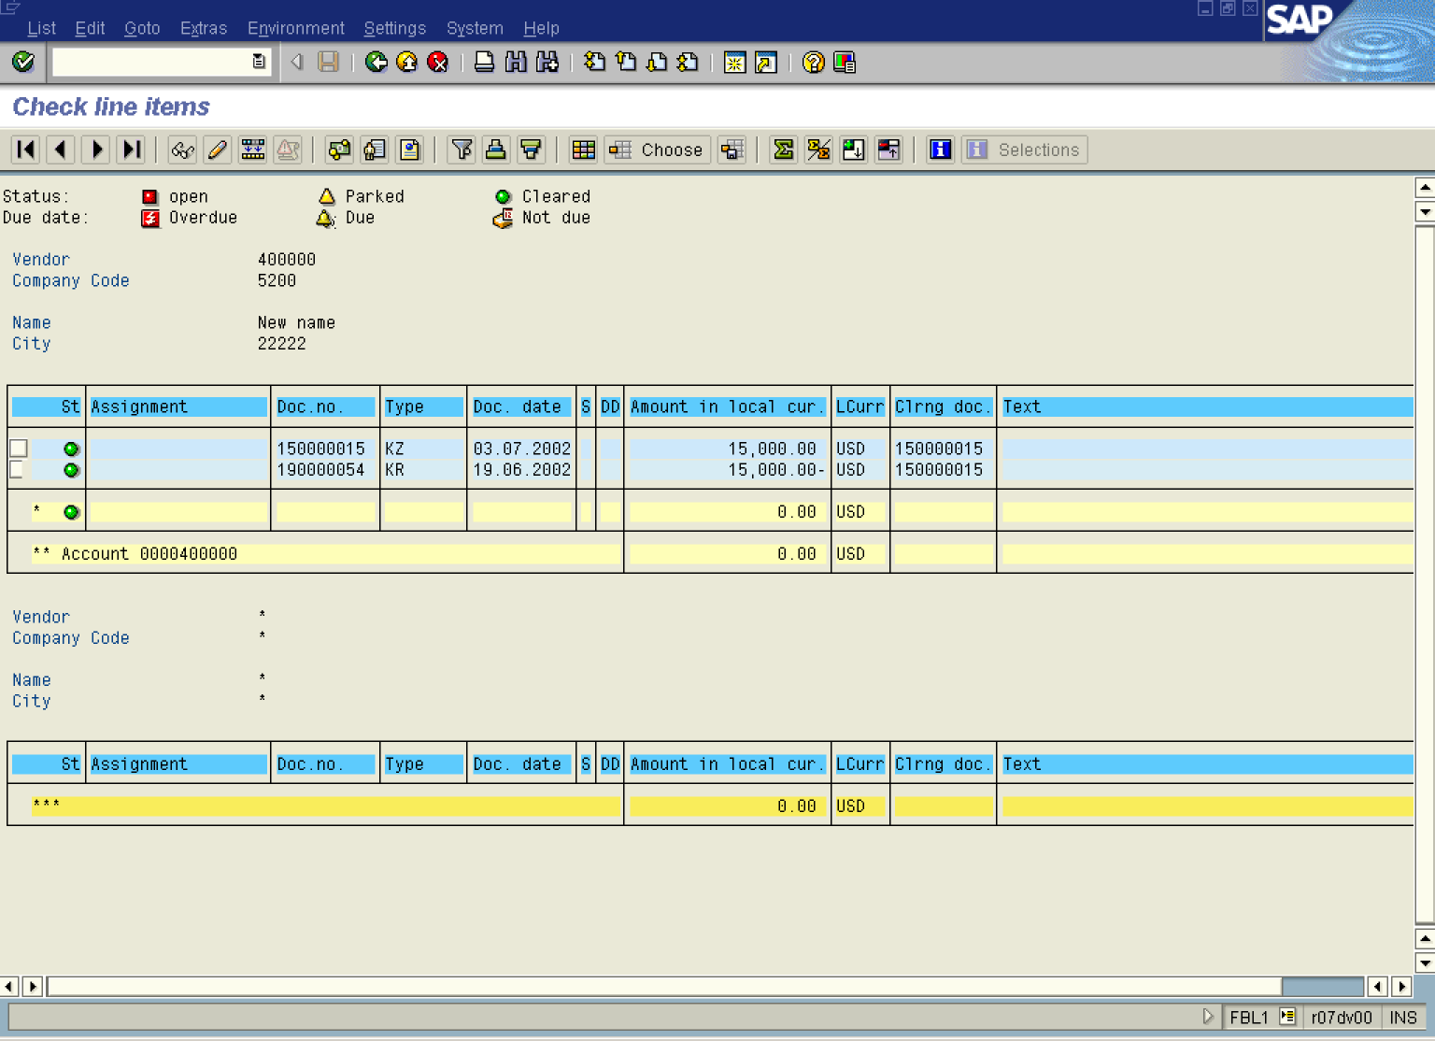

9. Double-click on line item 150000015 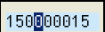 to display document details:
Display Document: Line Item 002

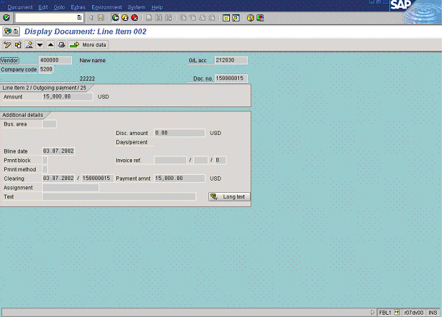

10. Click Back Button .

Check line items

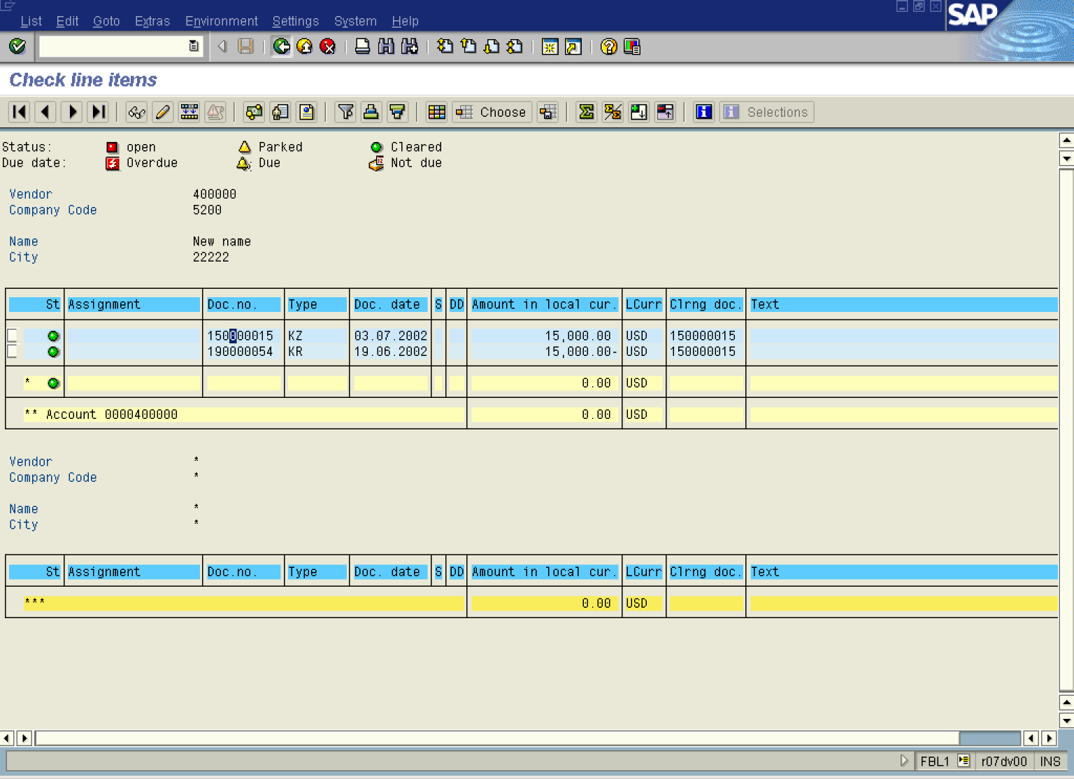

11. Click Back Button .

Display Check Information

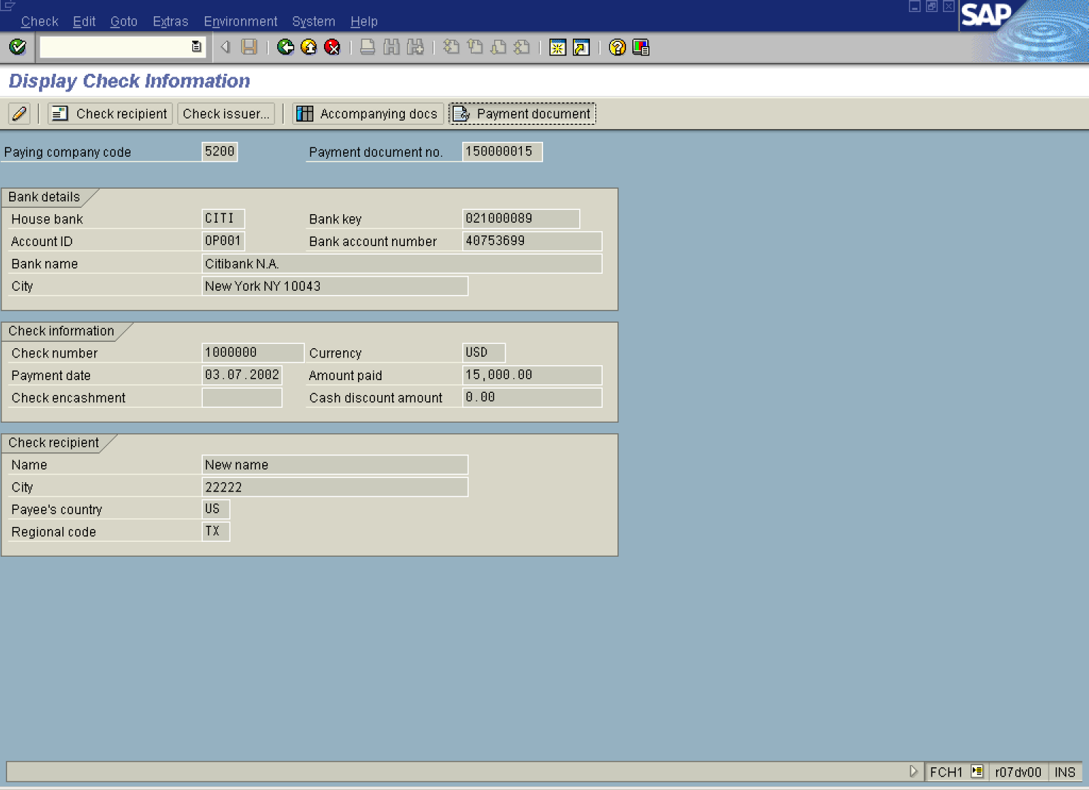

12. Click Payment document Button . The system will display an overview of the accounting document posted when the check was issued:

Display Document: Overview

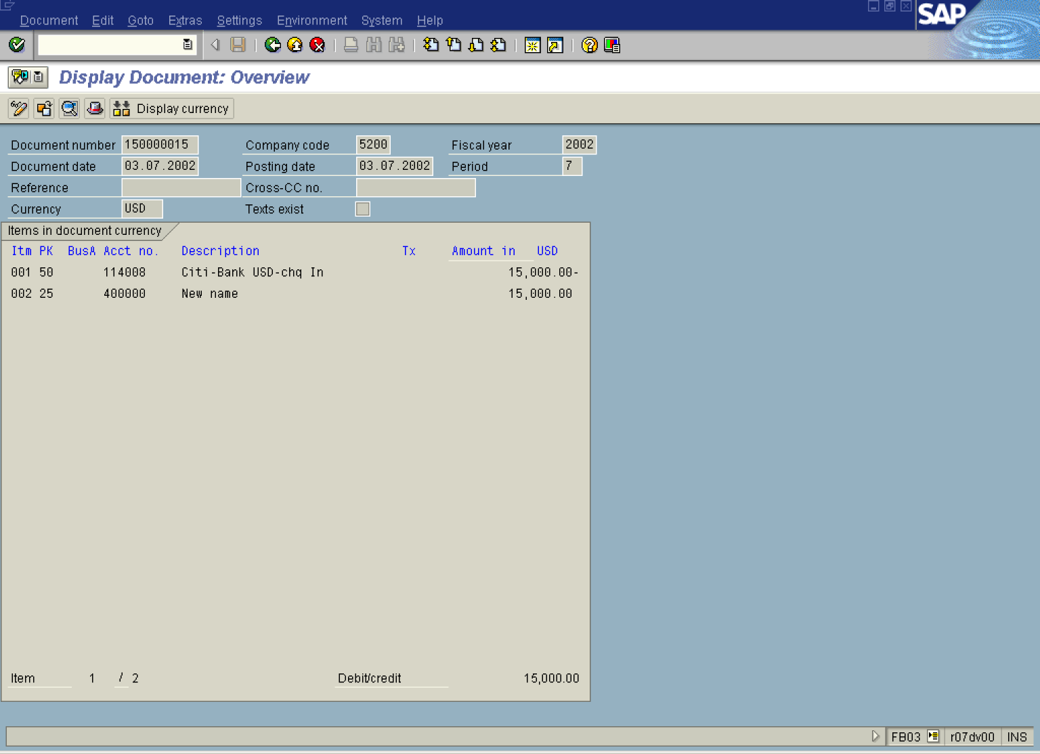

13. Click Back Button .

Display Check Information

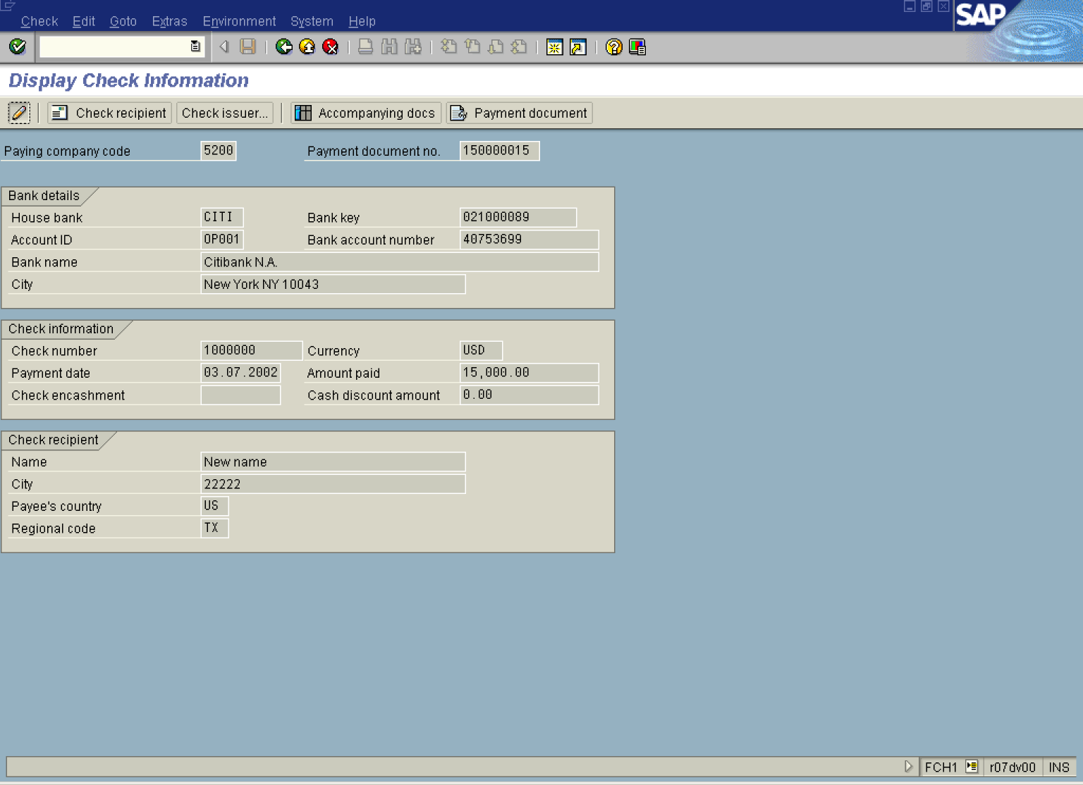

14. You can also cash the check using this trnsaction. Click Change Button .

Change Check Information / Cash Check

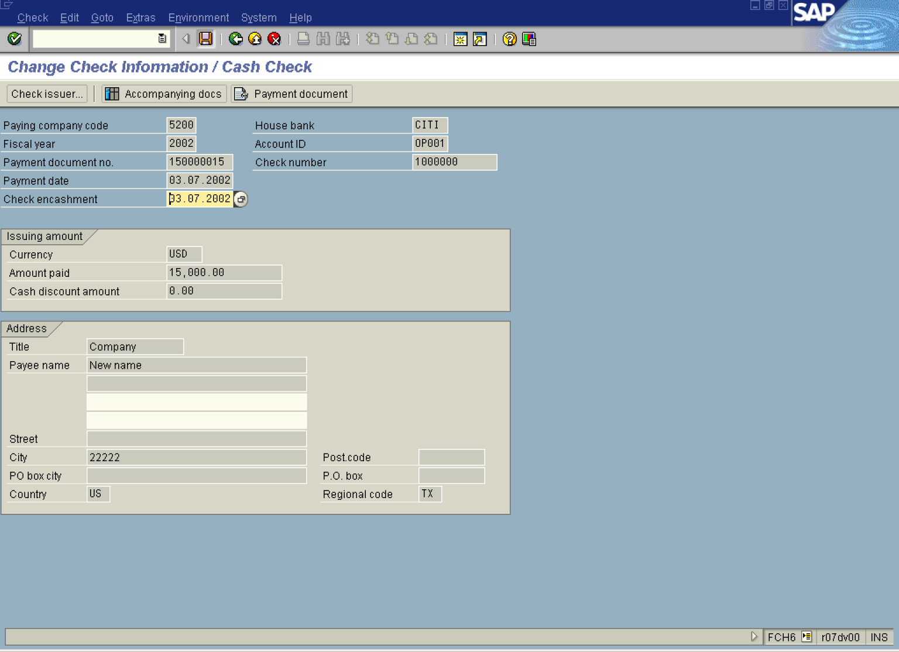

15. Click Enter Button to confirm your entries.

16. Update the following fields:

Field Name | Field Description | Values
Check encashment | Date on which the check was cashed at the bank by the payee. | Example: 030702

17. Click Enter Button to confirm your entries.

18. Click Save Button..

Display Check Information

